School of Science, Computing and Engineering Technologies

COS30045

LAB 4.1 Design Studio

Overview

In this lab you will be given a sample data set and asked to identify the different data and attribute types. You will also think about some questions about this data set that might be answered by a visualisation.

ardd_fatalities_Jan2020_0.xlsx (download from Canvas)

Download and review this data set before attempting this exercise.

1 Interpreting the data set

Complete the LAB 4.1 Quiz.

2 Visualisation Design

Think of three questions you would like to answer with that require a data visualistion.

For each data question you will need to consider the following:

Which data attributes (columns) do you need to answer this question?

Do you need to transform any of the data?

Does the data type change when you transform the data? If so how.

Make a sketch of how you think your visualisation might look and add to this document.

Your Question 1

**What is the distribution of road user fatalities by age group?**

* Data attributes needed: Age Group and Road User
* Transformations needed: Aggregate the count of fatalities for each age group or a grouped count by both Age Group and Road User.
* Data type changes: Age Group remains categorical. The count is derived from a transformation (quantitative type).
* Sketch idea: Bar chart with Age Group on the x-axis and number of fatalities on the y-axis.

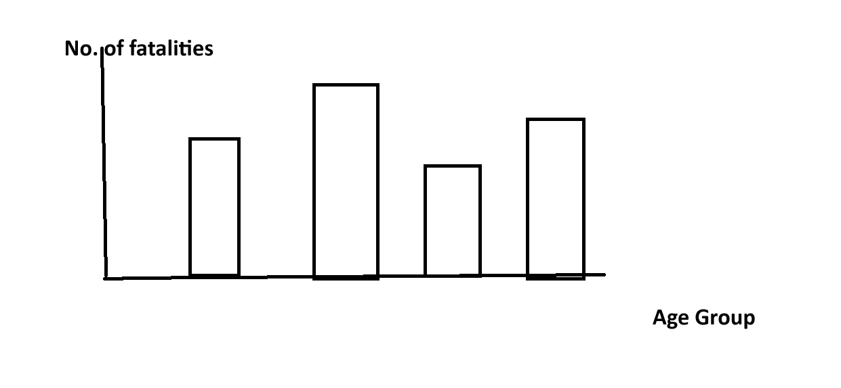

Your Question 2

**How do road fatalities vary by time of day?**

* Data attributes needed: Time or Crash Time
* Transformations needed: Extract hour or period from Time (e.g., Morning, Afternoon, Evening, Night). Therefore, group and count fatalities for each time range.
* Data type changes: Time is originally a time format so it has to transform to categorical (e.g., Morning). Fatality count is derived from aggregation (quantitative).
* Sketch idea: Line chart showing number of fatalities across different time ranges. For detecting peak crash hours.

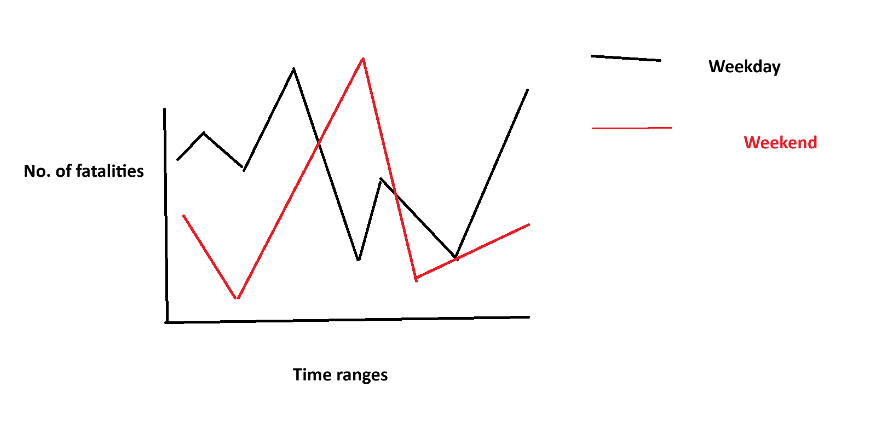

Your Question 3

**Which road user group has the highest number of fatalities across different regions?**

* Data attributes needed: Road User and Region
* Transformations needed: Count number of fatalities per Road User per Region.
* Data type changes: Road User and Region are categorical, otherwise fatality count is a transformed quantitative value.
* Sketch idea: Stacked bar chart with Region on x-axis, counts of each Road User type stacked or color-coded.

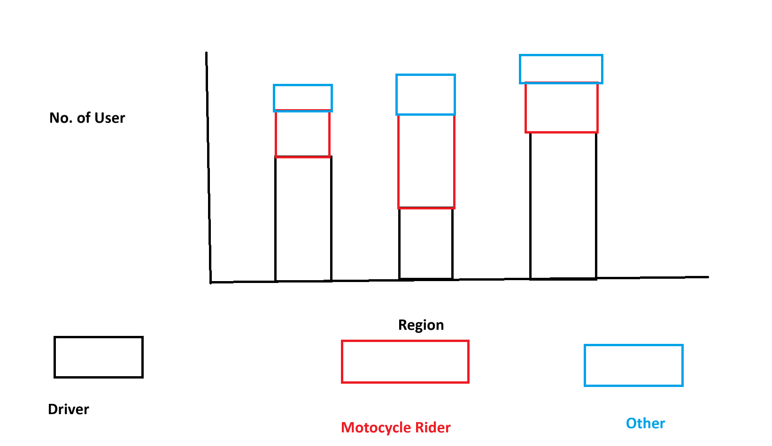

Include this file as evidence for your Demonstration 2